

**VISVESVARAYA TECHNOLOGICAL UNIVERSITY**

Jnana Sangama, Belagavi – 590014.

**Internship Report**

**On**

**“Real Time Air Pollution Monitoring System”**

*Submitted in partial fulfillment of the requirement for the award of 7th semester of*

**BACHELOR OF ENGINEERING**

**In**

**INFORMATION SCIENCE & ENGINEERING**

**AND**

**ELECTRONICS AND COMMUNICATION ENGINEERING**

**By**

**Deepshika K 1AP22EC401**

**Tejashwini M 1AP21IS039**

**Vasudha M R 1AP21IS044**

**2024 - 2025**

**DEPARTMENT OF ISE & ECE**

**A P S COLLEGE OF ENGINEERING**

**Anantha Gnana Gangothri,**

**NH-209, Kanakapura Road, Somanahalli, Bengaluru-560116.**

**Project Completion Certificate**

I, Deepshika K (Roll No: 1AP22EC401), hereby declare that the material presented in the Project Report titled **"Real Time Air Pollution monitoring system"** represents original work carried out by me in the **Department of Electronics and Communication** at the **APS college of Engineering, Bangalore** during the tenure **2 October, 2024 – 12, December, 2024**.

With My signature, I certify that:

* I have not manipulated any of the data or results.
* I have not committed any plagiarism of intellectual property and have clearly indicated and referenced the contributions of others.
* I have explicitly acknowledged all collaborative research and discussions.
* I understand that any false claim will result in severe disciplinary action.
* I understand that the work may be screened for any form of academic misconduct.

**Date**: **Student Signature**:

In my capacity as the supervisor of the above-mentioned work, I certify that the work presented in this report was carried out under my supervision and is worthy of consideration for the requirements of the B.Tech. Internship Work.

**Advisor’s Name**: Dr. Prakash Jadhav **Guide Name**: AKHIL SAI

**Advisor’s Signature Guide Signature**

**Project Completion Certificate**

I, Tejashwini M(Roll No: 1AP21IS039)hereby declare that the material presented in the Project Report titled **" Real Time Air Pollution monitoring system "** represents original work carried out by me in the **Department of Information Science and Engineering** at the **APS college of Engineering, Bangalore** during the tenure **2 October, 2024 – 12, December, 2024**.

With My signature, I certify that:

* I have not manipulated any of the data or results.
* I have not committed any plagiarism of intellectual property and have clearly indicated and referenced the contributions of others.
* I have explicitly acknowledged all collaborative research and discussions.
* I understand that any false claim will result in severe disciplinary action.
* I understand that the work may be screened for any form of academic misconduct.

**Date**: **Student Signature**:

In my capacity as the supervisor of the above-mentioned work, I certify that the work presented in this report was carried out under my supervision and is worthy of consideration for the requirements of the B.Tech. Internship Work.

**Advisor’s Name**: **Guide Name: AKHIL SAI**

**Advisor’s Signature Guide Signature**

**Project Completion Certificate**

I, Vasudha M R(Roll No: 1AP21IS044), hereby declare that the material presented in the Project Report titled **" Real Time Air Pollution monitoring system "** represents original work carried out by me in the **Department of Information Science and Engineering** at the **APS college of Engineering, Bangalore** during the tenure **2 October, 2024 – 12, December, 2024**.

With My signature, I certify that:

* I have not manipulated any of the data or results.
* I have not committed any plagiarism of intellectual property and have clearly indicated and referenced the contributions of others.
* I have explicitly acknowledged all collaborative research and discussions.
* I understand that any false claim will result in severe disciplinary action.
* I understand that the work may be screened for any form of academic misconduct.

**Date**: **Student Signature**:

In my capacity as the supervisor of the above-mentioned work, I certify that the work presented in this report was carried out under my supervision and is worthy of consideration for the requirements of the B.Tech. Internship Work.

**Advisor’s Name**: **Guide Name: AKHIL SAI**

**Advisor’s Signature Guide Signature**

**Evaluation Sheet**

**Title of the Project: Real Time Air-Pollution Monitoring System**

**Name of the Students: Deepshika K (1AP22EC401)**

**Tejashwini M (1AP21IS039)**

**Vasudha M R (1AP21IS044)**

**External Supervisor:**

**Internal Supervisor:**

**Date:**

**Place:**

**ABSTRACT**

The proposed project will develop a Real-Time Air Pollution Monitoring System that will utilize IoT and web technologies to track, analyze, and alert users about air quality parameters. The system will incorporate a Raspberry Pi, an MQ135 gas sensor for air quality detection, and a DHT11 sensor for temperature and humidity measurement. It will also integrate the API server to provide additional pollutant data, including PM10, PM2.5, carbon monoxide, nitrogen dioxide, sulfur dioxide, and ozone.

The system will feature a Flask-based web application with a user-friendly interface, enabling users to access real-time and historical data by inputting specific dates and times. Alerts will be generated dynamically when air quality parameters exceed predefined safe thresholds, ensuring timely action. Additionally, an automated buzzer alert mechanism will notify users of hazardous conditions in real-time.

By integrating IoT devices, RESTful APIs, and real-time data processing, the project will aim to enhance environmental monitoring capabilities. It will emphasize raising awareness about air quality issues and promoting proactive measures to mitigate their impact, ultimately contributing to healthier living environments.

|  |
| --- |
| **TABLE OF CONTENTS**      **CHAPTER 1**  **INTRODUCTION**   * 1. **OBJECTIVE…………………………………………………………….1**   2. **PROBLEM STATEMENT………………………………………....1**   **CHAPTER 2**  **APPLICATION………………………………..………………….……........2-3**  **CHAPTER 3**  **COMPONENTS………………………………………….......................4-6**  **CHAPTER 4**  **FLOWCHART…………………………………………………….…….........7**  **CHAPTER 5**  **CONCLUSION……………...……………………………………….…........8**  **CHAPTER 6**  **FUTUREWORK…………………………………………………..….………..9**  **CHAPTER 7**  **APPENDIX**  **8.1 PSEUDO CODE……………………………………………………….10** |

**CHAPTER 1**

**INTRODUCTION**

**1.1 Objective**

The project aims to enable real-time air quality monitoring by utilizing IoT sensors and online APIs for precise pollutant data collection. It is designed to trigger automated alerts through a buzzer for hazardous conditions and provide actionable insights for improved air quality management.

**1.2 Problem Statement**

Air pollution significantly impacts human health and the environment, with rising levels of hazardous pollutants like PM2.5, PM10, and gases such as CO, NO₂, and SO**₂**. These pollutants contribute to severe respiratory and cardiovascular diseases, environmental degradation, and reduced quality of life. There is an increasing need for a comprehensive system that can monitor air quality in real time, integrate multiple sensors to collect data, and present the information in an accessible, user-friendly interface. The system should also provide timely alerts for hazardous conditions and suggest actionable insights for individuals and authorities.

**Lack of Awareness:** Many people are unaware of real-time air quality conditions in their surroundings, leading to exposure to harmful pollutants.

**Delayed Monitoring**: Existing monitoring systems often lack real-time capabilities, resulting in delayed responses to hazardous air quality levels.

**Health Risks:** Prolonged exposure to high levels of pollutants, such as PM2.5, carbon monoxide, and ozone, poses severe health risks, especially for vulnerable populations.

**Manual Intervention:** Current systems do not offer automated responses, requiring users to take manual actions to mitigate risks, such as turning on air purifiers.

**Integration Challenges:** Many air quality monitoring solutions lack integration with other smart devices, limiting their usability in modern smart homes or environments.

**Localized Data Gaps:** Global or regional air quality APIs may not provide granular data for specific locations, making local sensor integration necessary.

**CHAPTER 2**

**APPLICATION**

1. **Environmental Monitoring**:

* Provides real-time air quality data for identifying pollution hotspots and trends.
* Assists environmental agencies in monitoring urban, industrial, or rural areas.

1. **Public Health**:

* Alerts individuals and communities about hazardous air quality levels.
* Supports health organizations in tracking and mitigating the impacts of air pollution.

1. **Urban Planning**:

* Guides city planners in designing eco-friendly urban spaces.
* Helps in evaluating the effectiveness of pollution control measures.

1. **Educational Use**:

* Serves as a tool for educational institutions to teach environmental science and IoT applications.

1. **Smart Cities**:

* Integrates with other smart city systems to provide centralized pollution control.
* Enables data sharing with stakeholders for collaborative decision-making.

1. **Research and Analytics**:

* Facilitates long-term studies on air quality and its health impacts.
* Provides data for AI/ML-based prediction models for forecasting air quality trends.

1. **Industrial Applications**:

* Monitors emissions near factories and industrial zones to ensure compliance with regulations.
* Helps businesses adopt eco-friendly practices by tracking pollutant levels.

1. **Policy-Making**:

* Supplies policymakers with reliable data for creating and implementing environmental regulations.

1. **Personal Use**:

* Assists individuals with respiratory issues by providing real-time air quality alerts.
* Helps households in ensuring a safe indoor and outdoor environment.

**CHAPTER 3**

**COMPONENTS**

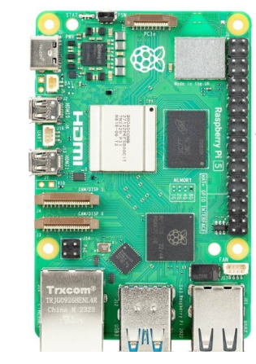**Hardware Components**

1. **Raspberry Pi -**

Acts as the control unit for data Processing and integration. A low-cost, single-board computer, often used in DIY projects. It provides computing power for running the system's software, interfacing with sensors, and managing the display. It is typically powered via a 5V micro-USB power supply.

1. 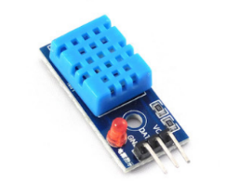**DHT11 Sensor –**

Measures temperature and humidity. A basic temperature and humidity sensor that provides accurate readings for indoor air quality monitoring. It uses a digital signal to provide temperature (°C) and humidity (%) data, which is crucial for assessing environmental comfort.

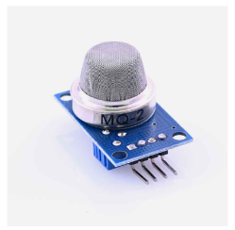

1. **MQ135 Sensor –**

Detects air pollutants such as carbon dioxide and ammonia. A semiconductor-based sensor designed to detect harmful gases like ammonia, carbon dioxide, benzene, and smoke. It is ideal for air quality monitoring as it provides an analog output related to gas concentrations, allowing the system to detect pollution levels.

1. 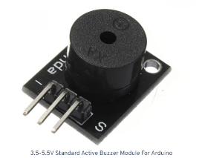**Buzzer –**

Alerts users to hazardous pollutant levels. A simple electronic device used for alerting users when air quality parameters exceed predefined unsafe levels. The buzzer emits a sound when pollutant levels go beyond threshold limits, drawing attention to hazardous conditions.

1. 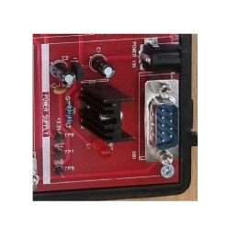**Power Supply –**

Powers the Raspberry Pi and sensors. A 5V DC adapter (or a portable power bank) is used to supply power to the Raspberry Pi and its peripherals. It ensures stable power for continuous monitoring and operation of all connected devices.

1. 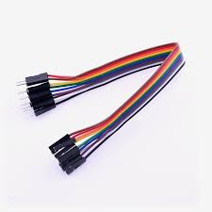**Connecting Wires –**

Facilitates connections between hardware components. wires are flexible strands of metal, typically copper, used to establish electrical conductivity between different components in an electronic circuit, allowing electric current to flow from one point to another.

1. 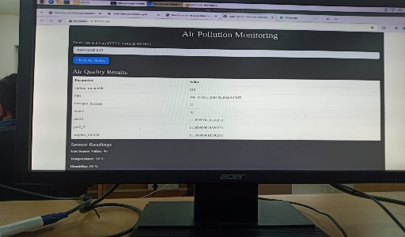**Monitor –**

Displays real-time outputs directly from the Raspberry Pi. A display screen connected to the Raspberry Pi, used to show real-time data from the sensors. It can display information such as temperature, humidity, air quality index, and pollutant levels, allowing users to view and interact with the data visually.

**Software Requirements**

1. **Operating System -**

Raspberry Pi OS (Raspbian)

1. **Python Programming Language -**

Used for data acquisition and processing.

1. **Flask Framework -**

Develops the web application for real time data display.

1. **API server -**

Retrieves external quality data.

1. **Libraries and Modules -**

Required Python libraries, such as:

* Adafruit_DHT for sensor interfacing.
* Flask for web server deployment.
* Requests for API integration.
* GPIO for hardware control.

1. **Database -**

For storing historical quality data.

1. **Web Browser -**

For accessing the Flask-based web interface.

**CHAPTER 4**

**FLOWCHART**

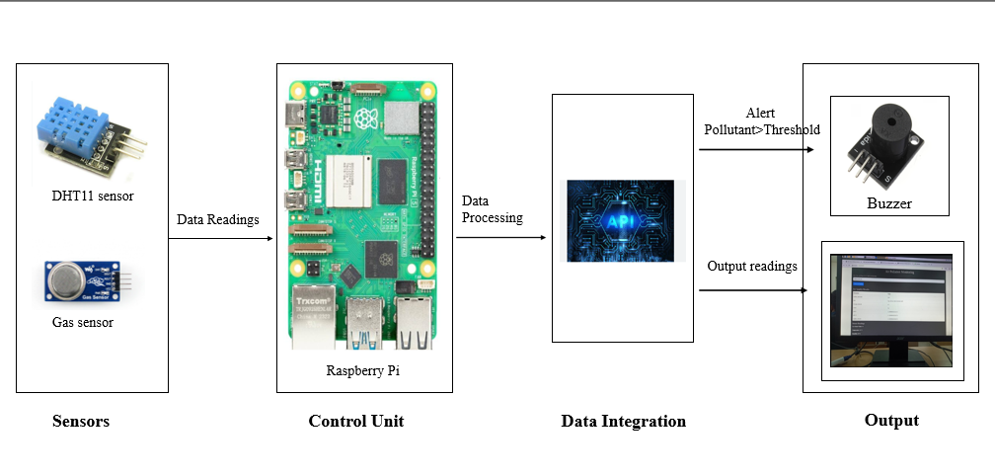

The flow diagram illustrates the Real-Time Air Pollution Monitoring System, starting with the Sensors section, which includes the DHT11 sensor for temperature and humidity measurements and a gas sensor (e.g., MQ135) for detecting air quality. These sensors collect real-time environmental data and transmit it to the Control Unit, represented by a Raspberry Pi. The Raspberry Pi processes the data using predefined thresholds to classify air quality levels and integrates additional pollutant data through APIs for enhanced monitoring. The Data Integration step combines sensor readings with external data sources to ensure accuracy and comprehensiveness. Based on the processed data, the system generates output a buzzer is triggered when pollutant levels exceed the threshold, providing immediate alerts, and a web interface displays the readings dynamically for user monitoring. This integrated system highlights the use of IoT and web technologies for efficient environmental monitoring and proactive responses.

**CHAPTER 5**

**CONCLUSION**

The Real-Time Air Pollution Monitoring System was designed to address the critical challenge of air pollution by providing a continuous, real-time method to track air quality. The system utilized various sensors, including gas sensors (for pollutants such as CO, NO₂, and SO₂) and environmental sensors (for temperature and humidity), all powered by a Raspberry Pi. It not only monitored pollutants but also presented the data in an easy-to-understand format on a web interface, enabling users to receive alerts and take timely actions in response to hazardous air quality levels.

The system was envisioned to have the potential for future scalability and expansion. Additional sensors could be incorporated to enable more comprehensive environmental monitoring. The data collected could be stored and analyzed over time to better understand air quality patterns, identify pollution hotspots, and inform policies related to environmental health.

Further enhancements to the project could include the integration of machine learning algorithms to predict air quality based on historical data, providing users with forecasts to better prepare for unhealthy air days. The system could offer access to global data and promote collaborations among various stakeholders, such as governments, health organizations, and the public.

**CHAPTER 6**

**FUTURE WORK**

* **Predictive Analysis:**
* **Future Air Quality Prediction:** Use machine learning (e.g., ARIMA, LSTM models) to forecast air quality for the next few hours or days.
* **Seasonal Trends:** Analyze seasonal patterns to predict pollution spikes during specific times of the year.
* **Public Health Integration:**
* **Health Recommendations:** Provide health advice based on AQI levels, such as avoiding outdoor activities or wearing masks.
* **Health Risk Analysis:** Correlate pollution data with health impacts for vulnerable groups like children, elderly, or individuals with respiratory issues.
* **Reporting and Analytics:**
* **Monthly/Yearly Reports:** Generate detailed reports with charts and statistics for policymakers or environmental organizations.
* **Comparative Analysis:** Compare pollution levels between regions or time periods.
* **Advanced Features:**
* **Air Purifier Integration:** Automate indoor air purifier settings based on outdoor pollution levels.
* **Geofencing:** Trigger alerts when a user enters a highly polluted area.
* **Sustainable Practices:**
* **Community Engagement:** Encourage citizens to report pollution sources or participate in tree plantation drives.

**CHAPTER 7**

**APPENDIX**

**7.1 Pseudo Code**

BEGIN

// Initialization

1. Initialize Raspberry Pi GPIO pins.

2. Set up DHT11 sensor for temperature and humidity readings.

3. Set up MQ135 gas sensor for air quality readings.

4. Configure Buzzer for alert mechanism.

5. Establish Flask server for web application.

6. Connect to the API server for external pollutant data.

